1. Key Contacts 1
2. Floor Plan set up – (update) 2
3. Venue set up & logistics 3
4. Catering (update) 4
5. Parking: 5
6. Run sheet 6

Key Contacts
Sime
Name | Title | Role | Contact Details
Stuart Donnelly | Agile Coach | Main contact / Event organiser and facilitator | M: 0434 411 789  E: stuart.Donnelly@hastingsdeering.com.au
Dee Whiffin | Enterprise Agile Coach | Second Contact / Event organiser | E: dee@sime.com
Nicholas Gausel | Digital Graduate | Media Desk operator | E: Nicholas.Gausel@hastingsdeering.com.au

BTP Conference & Exhibition Centre
Name | Title | Role | Contact Details
Greg Volich | General Manager | Venue Manager | M: 0435 886 653  P: 07 3166 2000  E: greg@btpconference.com.au
Andrea Mellican | Bookings Manager | Bookings Manager | P: 07 3166 2000  E: TBA

Floor Plan set up – (update)
Requesting usual set up see floor plan below:
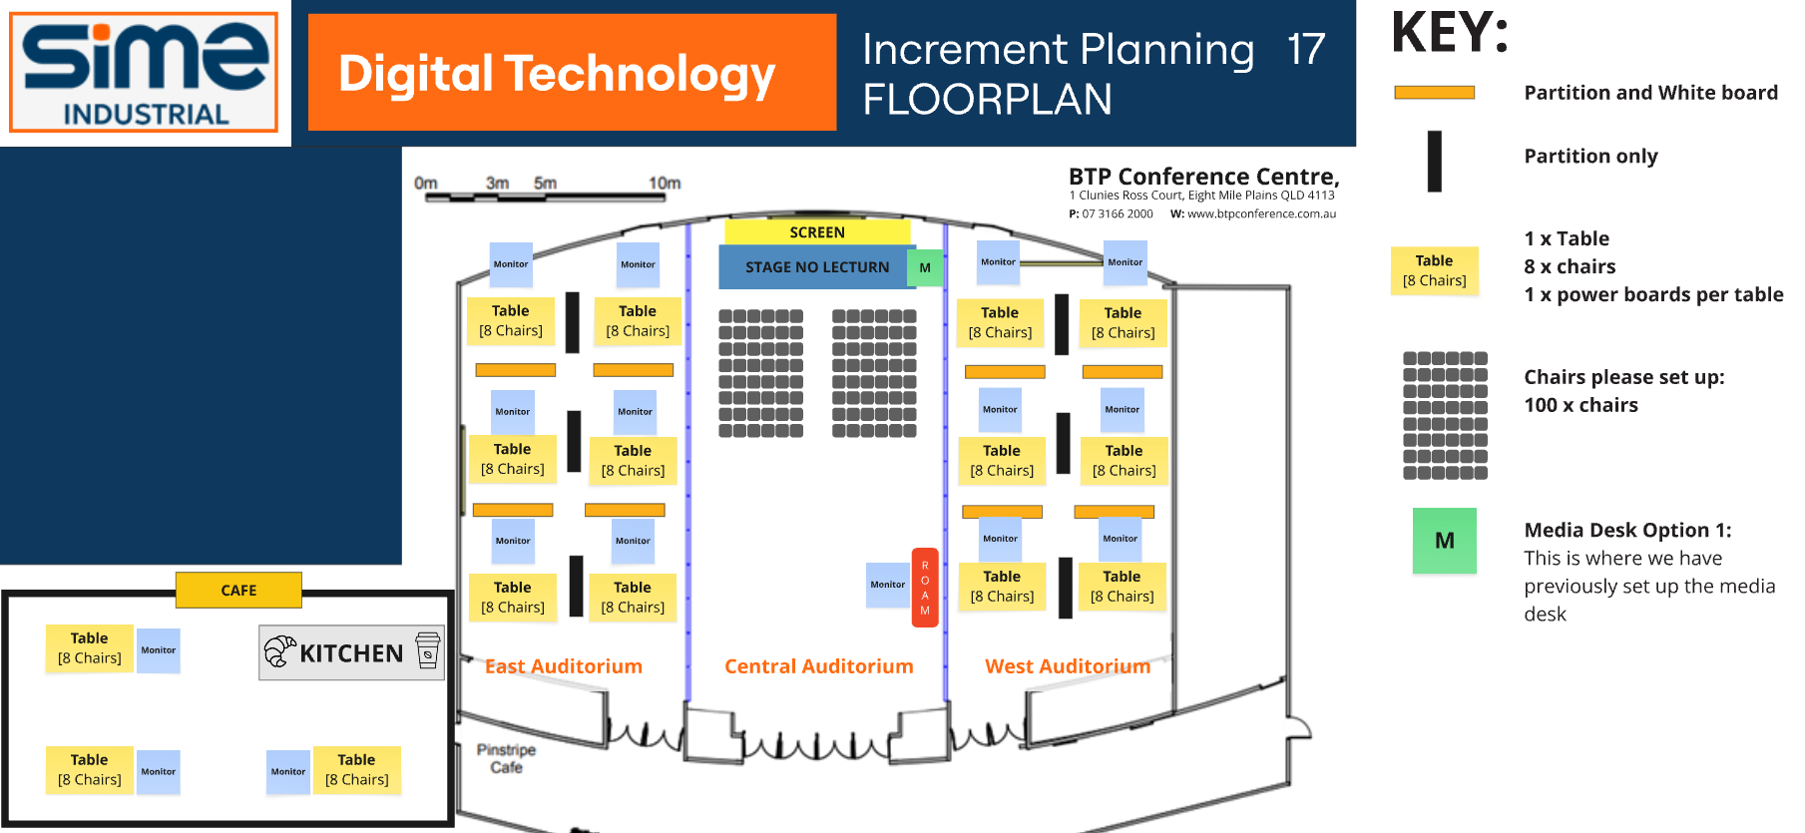

Venue set up & logistics
Details regarding delivery of equipment and set up:

  - Network: Set up window on Monday 20 OCT 25 9am – 4pm
BTP Conference tech contact to forward to our Network Team of:
Ben Anderson / E: ben@btpconference.com.au / M: 0419 842 986
  - Monitors: To be dropped off on 20 OCT 25 … 9 am – 4pm and stored under your stairs as usual

Catering (update)
 | Time | Tuesday, 21 Oct 2025
Morning Tea | 10:30am | Sweet:  Upside down peach and vanilla friand V GF  Savoury:  Neapolitan pizza with buffalo mozzarella V
Lunch | 12:30pm | OPTION 5 - SUBSTANTIAL BUFFET LUNCH  Salad  BBQ sweet potato, roasted fennel, ancient grains, goat’s cheese, pomegranate arils and sweet red onions V GF  Salad  Beetroot, fetta, charred broccoli, tomato heirloom, roasted hazelnuts and lemon tarragon dressing V GF  Salad  Falafel and pumpkin, tomato, tabbouleh and tahini dressing VE GF  Hot protein  Can we replace with the following Hot protein choice from Option 4:  Lemon myrtle infused chicken, aniseed myrtle rice pilaf and wattle seed yoghurt GF  Hot vegan  Seasonal vegetable tagine, saffron cous cous, dried fruit, preserved lemon and green olive salsa VE  Hand item  Assorted maki sushi rolls with soy dipping sauce GF  All served with bread roll and butter
Afternoon Tea | 2:30pm | Sweet:  Homemade Nutella filled croissant with hazelnuts and vanilla syrup V  Savoury:  Fresh baked croissant with shaved ham, gourmet tomato and sliced Swiss cheese

Parking:
Parkable will be on site from 6:30am, you mentioned that we won’t advertise the Conference as some people not attending use this to get free parking.
Parking spots confirmed as below: Parking: [107], Purple: 22, Grey: 55, Green: 30
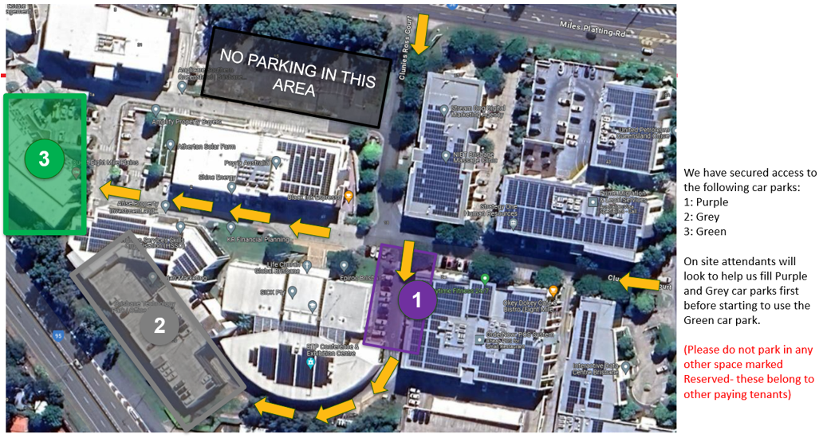

Run sheet

